Fill in the missing blanks to name what is in the picture.
Then match up the picture pairs to show how they grow.
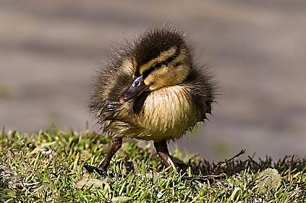
D _ _ _ _ _ _ _ |  | F _ _ _
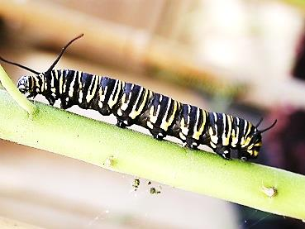 |  | 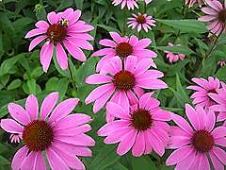
C _ _ _ _ _ _ _ _ _ _ |  | F _ _ _ _ _ _
 |  | 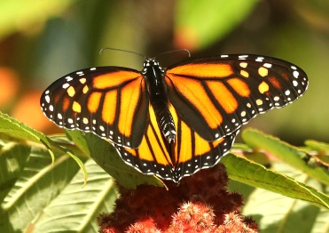
T _ _ _ _ _ _ _ |  | B _ _ _ _ _ _ _ _
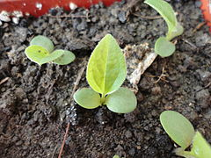 |  | 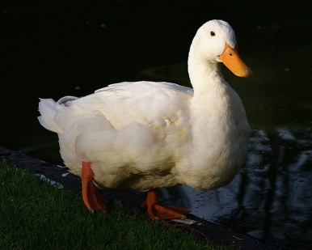
S _ _ _ _ _ _ _ _ |  | D _ _ _

